Introduction
Carpal tunnel syndrome (CTS) is the most common peripheral compressive neuropathy, with a high prevalence in middle-aged males and females. It significantly affects their day-to-day activities (1). CTS is typically diagnosed through a combination of clinical evaluation and nerve conduction studies (NCS). NCS is used to classify the severity of CTS, forming the basis for its treatment. Mild and moderate cases are usually managed conservatively with splinting and oral medications, while severe cases require surgical release (2). However, NCS is a time-consuming, painful, and relatively expensive procedure that may not be available in all facilities (3). In comparison, high-resolution ultrasound (HRUS) offers several advantages — it is painless, quick, readily available, and relatively cost-effective. HRUS parameters have already been established to have similar diagnostic accuracy to NCS for diagnosing CTS. However, it is unclear whether HRUS can effectively grade the severity of CTS (4-6). The purpose of this study is to evaluate the diagnostic potential of HRUS for grading the severity of carpal tunnel syndrome.

Materials and methods

Study design and patients

This is a prospective descriptive study conducted in the Department of Radiology and Imaging at Nizam’s Institute of Medical Sciences in Hyderabad, India. The study was approved by the institutional ethics committee and informed consent was obtained for all patients. The study included 42 cases of CTS confirmed by nerve conduction studies. All diagnosed patients were further classified into severe (27) and non-severe (15) cases based on the nerve conduction study.

Nerve conduction study

Sierra Wave 2-channel electromyography system was used for NCSs. The NCSs were performed by experienced NCS technicians under the supervision of a neurologist. NCS tests were performed on bilateral upper extremities of all participants, with the skin temperature kept at 32◦C. Severity of CTS was based on Padua classification (Figure 1) (7). All tests were performed in compliance with the guidelines set forth by the American Association of Neuromuscular and Electrodiagnostic Medicine (8):
- Sensory nerve action potential (SNAP): Two surface cup electrodes applied to the index finger; the median nerve's action potential was antidromically recorded.
- Sensory nerve conduction velocity (SCV): The latency of the sensory nerve action potential waveform and the distance between the recording electrodes and the stimulation point are used to calculate velocity.
- Compound muscle action potential (CMAP): Two surface cup electrodes covering the abductor pollicis brevis were used to record the motor action potential.
- Distal motor latency (DML): The CMAP waveform was used to calculate DML.
In our study, all the cases classified as minimal, mild, and moderate CTS were grouped in the non-severe category and those classified as severe and extreme CTS were assigned to the severe category.
Figure 1. Electrophysiological severity classifications for CTS based on Padua classification (7):
1. Extreme CTS: absence of SNAP and CMAP.
2. Severe CTS: absence of SNAP and DML > 4.0 ms.
3. Moderate CTS: SCV < 44 m/s and DML > 4.0 ms.
4. Mild CTS: SCV < 44 m/s and DML < 4.0 ms.
5. Minimal CTS: “standard negative” hands with abnormal comparative or segmental tests.
6. Negative: normal findings on all tests.

Ultrasound imaging
Ultrasound imaging was performed for all patients within 24 hours after the nerve conduction study. Images were obtained with a high-resolution linear array transducer (8-22 MHZ) in Esaote Mylab 9xpTM (Esaote, Genoa, Italy). Patients were seated comfortably with the forearm placed on the lap with a pillow, the elbow was flexed with forearm straight and wrist in a neutral position, and the fingers were partially flexed. Ultrasound images were obtained at three levels: forearm, carpal tunnel inlet (inlet), and carpal tunnel outlet (outlet). The median nerve was scanned in both longitudinal and transverse planes (Figures 2a-b) (9,10).
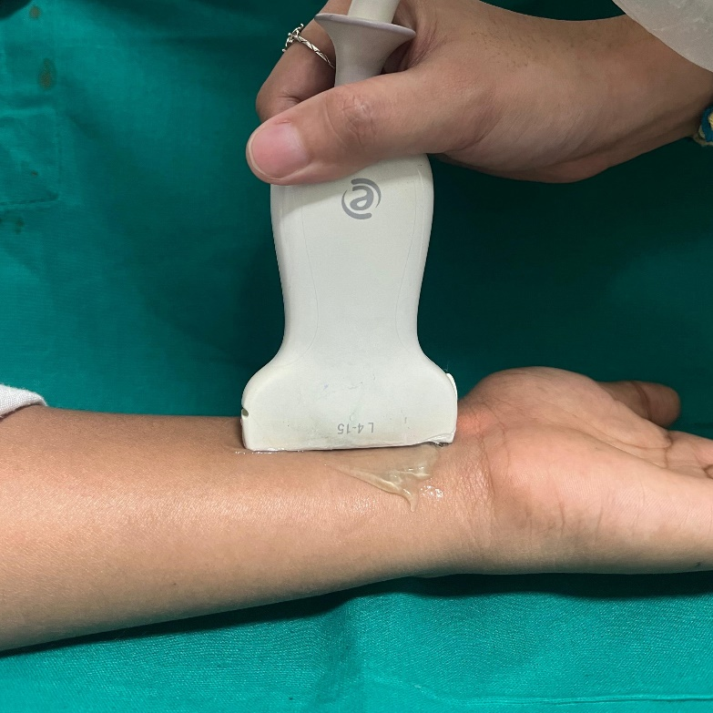
Figure 2a. Median nerve is scanned in longitudinal plane.
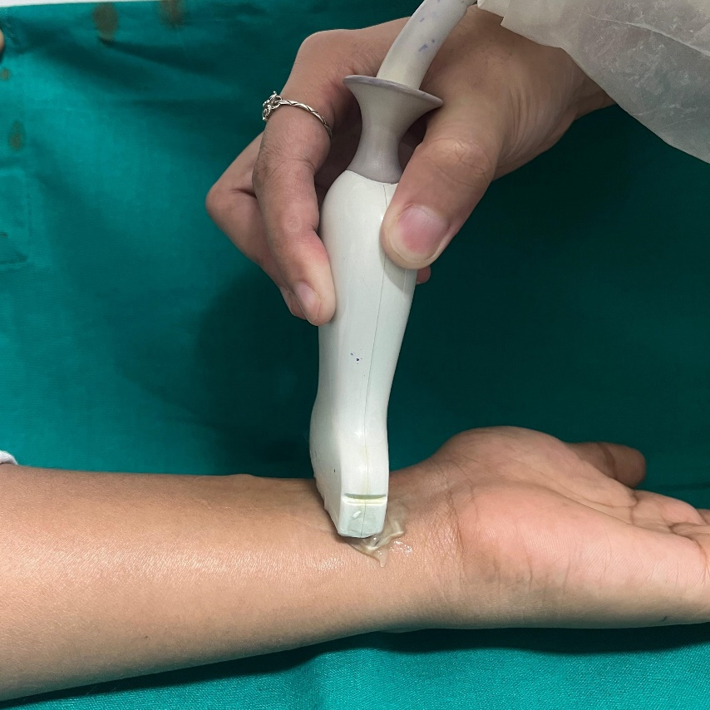
Figure 2b. Median nerve is scanned in transverse plane.

Grey-scale parameters
The landmark for forearm is situated between the ulna medially and the radius laterally, approximately 3 cm proximal to the wrist skin crease (Figure 3a). The landmark for inlet is between pisiform bone as the medial border and scaphoid bone as the lateral border (Figure 3b) (11). The landmark for outlet is positioned between the hook of hamate as the medial border and apex of trapezium as the lateral border (Figure 3c). The cross-sectional area (CSA) in mm² is measured at each of the three levels along the inner border of epineurium. At the same levels, the nerve's widest mediolateral and anteroposterior diameters were measured. The maximum thickness of the flexor retinaculum is measured at the outlet (Figure 4a). The distance between the palmar apex of the flexor retinaculum and a straight line drawn between the apexes of the trapezium and hamate bone is used to quantify the palmar bowing of the flexor retinaculum at the outlet. (Figure 4b) (12)

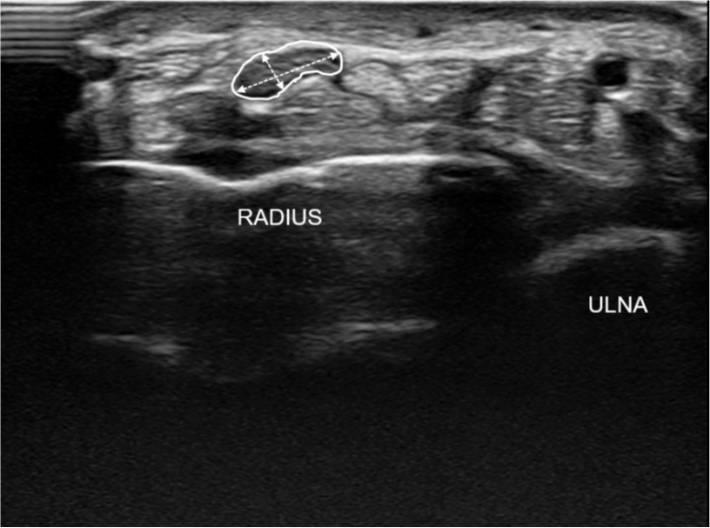

Figure 3a. Transverse view showing the measurement of cross-sectional area and anteroposterior and transverse diameter of the median nerve at forearm.

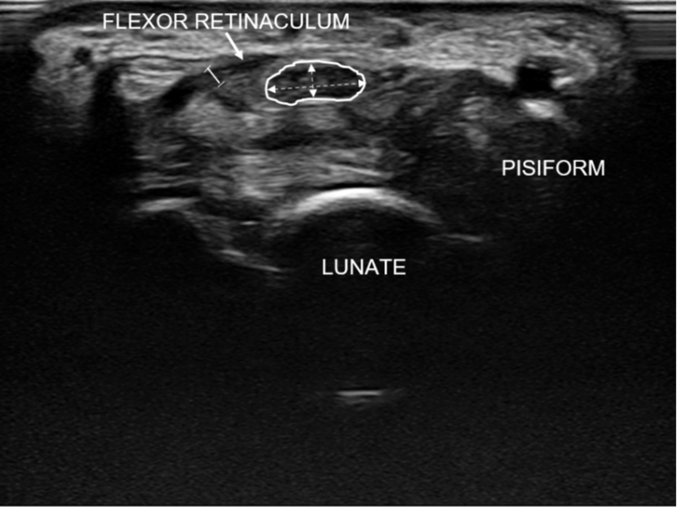
Figure 3b. Transverse view showing measurement at carpal tunnel inlet.

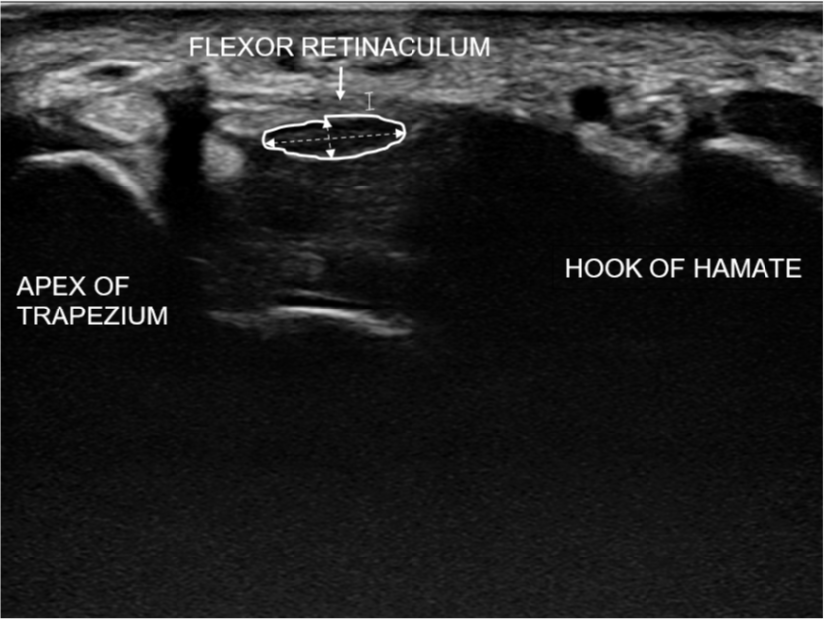
Figure 3c. Transverse view showing measurement at carpal tunnel outlet.

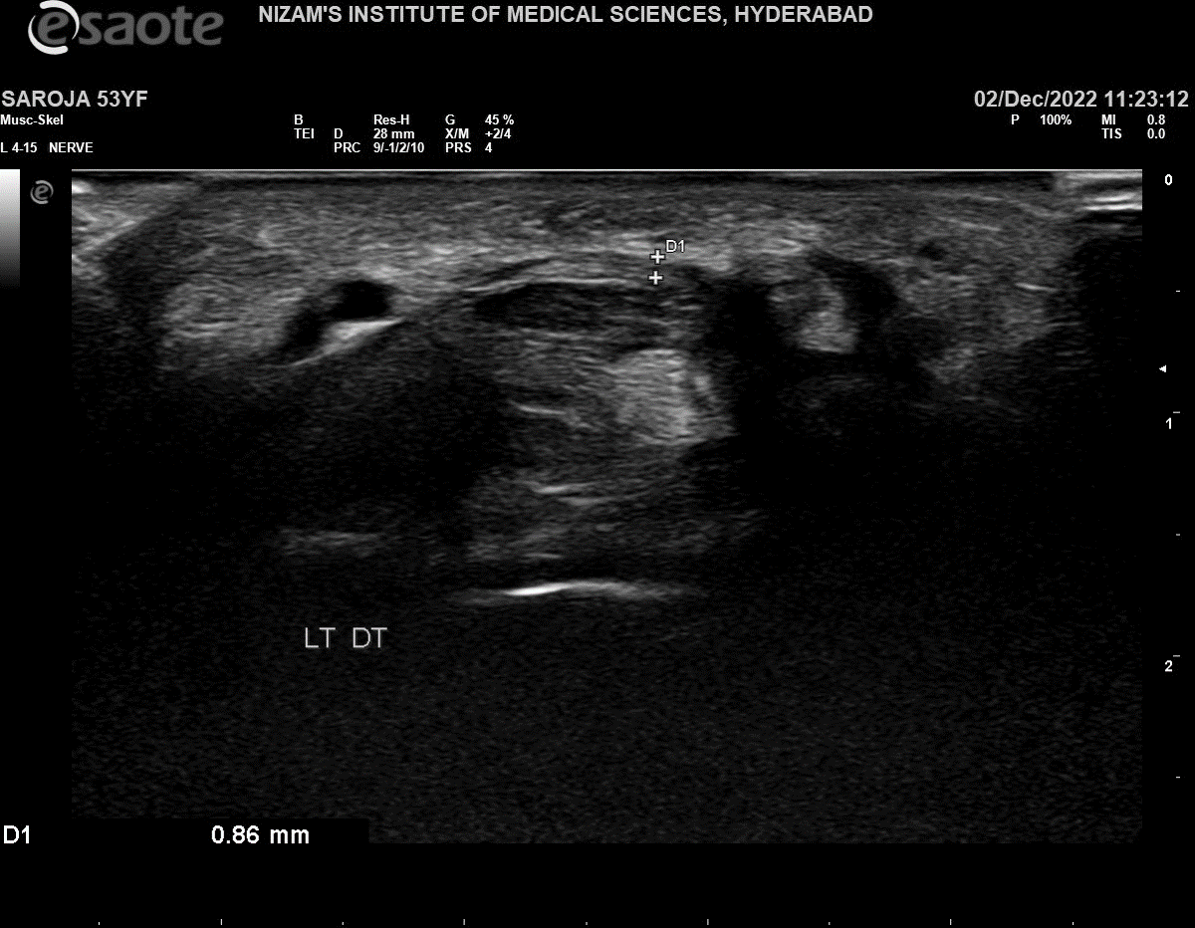
Figure 4a. Measuring maximum flexor retinaculum thickness at outlet.

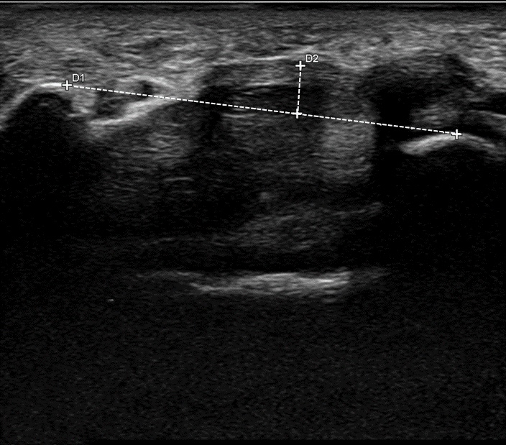
Figure 4b. Measuring palmar bowing ratio.

Derived parameters
- Swelling ratio: The ratio of the nerve's area at the inlet to its area at the outlet.
- Flattening ratio at the forearm, inlet and outlet: The ratio of the nerve's major axis to its minor axis, which is computed at these three locations.
- Wrist-forearm ratio: The ratio of the nerve's area at the inlet and its area at the forearm.
- Wrist–forearm difference: Difference between area at the forearm and area at the inlet.

Color Doppler parameter

Hypervascularity of the median nerve is assessed by color Doppler sand power Doppler imaging in the longitudinal view. The color gain is set to the maximum level and adjusted until no noise artifacts are seen (Figure 4c).
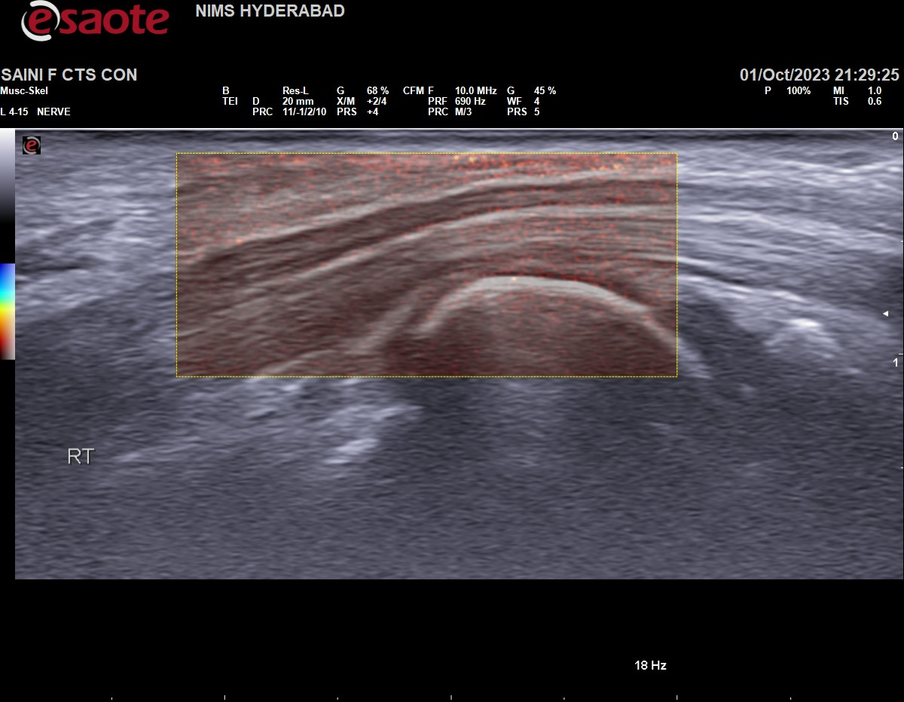
Figure 4c. Measuring vascularity score in longitudinal plane.

Hypervascularity was evaluated by scores based on El Miedany, et al.’s study (13):
Score 0: No color flow signal
Score 1: One single vessel within the nerve
Score 2: 2 or 3 single or 2 confluent vessels
Score 3: More than 3 single or more than 2 confluent vessels

Statistical analysis
Clinical history including age, sex, and side of disease were recorded. All data were entered into a Microsoft Excel sheet (Microsoft Corporation, Redmond, WA, USA) and analyses were performed using Medcalc. The CSA and ratios were expressed in means and standard deviation. An unpaired t-test was used to compare the severe and non-severe groups. ROC curves were used to determine the cutoff values, sensitivity, specificity, and best predictor. A p-value < 0.05 was considered statistically significant.

Results
Of the total 42 diagnosed cases, 27 (64%) were categorized as non-severe and 15 (36%) were categorized as severe cases of carpal tunnel syndrome. The mean age of those with severe disease was 56 years (range: 50-65 years), while those with non-severe disease had a mean age of 46 years (range: 33-62 years). Among these patients, 29 (69.1%) were female, 10 (34 %) of whom had severe disease, and 13 (30.9%) were male, 5 (38.4%) of whom had severe disease. An unpaired t-test (Table 1) was used to compare the grey scale and color Doppler values in severe (Figures 5a-c) and non-severe (Figures 6a-c) groups. The CSA at inlet (mean: severe – 15.80±6.062, non-severe – 11.04±4.090, P-value: 0.004) and outlet (mean: severe – 12.67±4.419, non-severe – 9.33±2.760, P-value: 0.004), the flattening ratio at outlet (mean: severe – 3.034±0.56, non-severe – -2.616±0.606, P-value: 0.032), wrist to forearm ratio (mean: severe – 1.53±0.44, non-severe – 1.23±0.34, P-value: 0.018), wrist to forearm difference (mean: severe – 5.6±5, non-severe – -2±3.4, P-value: 0.009) and vascularity score (mean: severe – 2.27±0.8, non-severe – 1.48±1.2, P-value: 0.035) showed statistically significant difference between the two groups.
Table 1. Unpaired t-test values comparing non-derived and derived grey scale parameters and color Doppler parameters between the severe and the non-severe group.
PARAMETERS | SEVERITY | MEAN | SD | P VALUE
NON-DERIVED PARAMETERS
CSA AT FOREARM (mm2) | SEVERE | 10.20 | 1.859 | 0.083
 | NON-SEVERE | 9.04 | 2.121
CSA AT INLET (mm2) | SEVERE | 15.80 | 6.062 | 0.004
 | NON-SEVERE | 11.04 | 4.090
CSA AT OUTLET (mm2) | SEVERE | 12.67 | 4.419 | 0.004
 | NON-SEVERE | 9.33 | 2.760
FR THICKNESS(MM) | SEVERE | 0.9240 | .23570 | 0.070
 | NON-SEVERE | 0.7641 | .28136
FR BOWING(MM) | SEVERE | 3.0333 | 1.08277 | 0.471
 | NON-SEVERE | 2.7870 | 1.03288
DERIVED PARAMETERS
SWELLING RATIO | SEVERE | 1.2960 | .49735 | 0.404
 | NON-SEVERE | 1.1969 | .26888
FLATTENING RATIO AT FOREARM | SEVERE | 2.5737 | .98158 | 0.590
 | NON-SEVERE | 2.4269 | .75029
FLATTENING RATIO AT INLET | SEVERE | 3.4260 | 1.10403 | 0.114
 | NON-SEVERE | 2.9582 | .76501
FLATTENING RATIO AT OUTLET | SEVERE | 3.0395 | .55941 | 0.032
 | NON-SEVERE | 2.6158 | .60634
WRIST FOREARM RATIO | SEVERE | 1.5360 | .44813 | 0.018
 | NON-SEVERE | 1.2332 | .34194
WRIST FOREARM DIFFERENCE | SEVERE | 5.60 | 5.054 | 0.009
 | NON-SEVERE | 2.00 | 3.408
COLOUR DOPPLER PARAMETERS
VASCULARITY SCORE | SEVERE | 2.27 | .799 | 0.035
 | NON-SEVERE | 1.48 | 1.252

Figure 5a. A 69-year-old female patient diagnosed as severe CTS by NCS has a CSA at forearm of 12mm².
Figure 5b. CSA at inlet measured at 28 mm².

Figure 5c. CSA at outlet measured at 18 mm² and a wrist forearm difference of 16 mm².

Figure 6a. 41-year-old female diagnosed as non-severe CTS by NCS has CSA at forearm measured at 7 mm².

Figure 6b. CSA at inlet measured at 8 mm².

Figure 6c. CSA at outlet measured at 9 mm², with wrist forearm difference of 1 mm².

ROC curve analysis (Table 2) was used to assess diagnostic ability of each parameter. Among the grey-scale and Doppler parameters, CSA at outlet had the largest AUC (AUC=0.759) (Figure 7a), and among the derived parameters, wrist-forearm difference had the largest AUC (AUC = 0.811) (Figure 7b). Both had 95% confidence intervals, making these parameters the best predictors of severity.
Using Youden's Index, the optimal cutoff for CSA at outlet was determined to be 11 mm². At this cutoff, CSA had a specificity of 94.5% and a sensitivity of 40%. The optimal cutoff for wrist-forearm difference was 5 mm², with a specificity and sensitivity of 92.5% and 40%, respectively, for diagnosis of severe CTS.

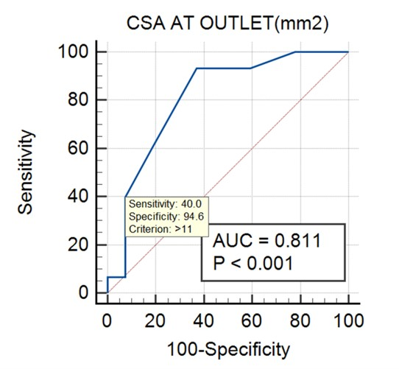
Figure 7a. ROC curve of CSA at outlet.

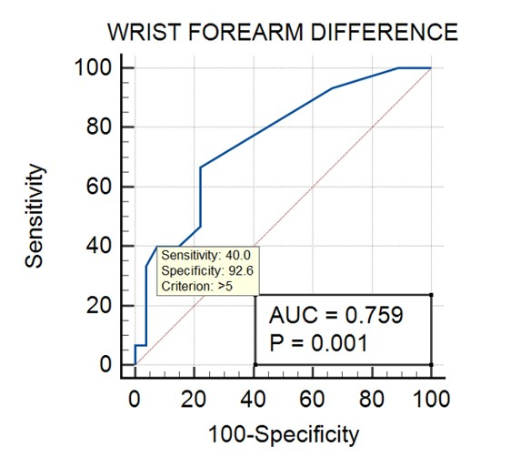
Figure 7b. ROC curve of wrist forearm difference of CSA.

Table 2.ROC analysis of non-derived, derived grey scale parameters and color Doppler parameters.
PARAMETERS | AREA UNDER THE CURVE | P VALUE
NON – DERIVED PARAMETERS
CSA AT FOREARM (mm2) | .669 | .072
CSA AT INLET (mm2) | .749 | .002
CSA AT OUTLET (mm2) | .811 | .001
FR THICKNESS(MM) | .696 | .037
FR BOWING(MM) | .588 | .351
DERIVED PARAMETERS
SWELLING RATIO | .477 | .803
FLATTENING RATIO AT FOREARM | .553 | .572
FLATTENING RATIO AT INLET | .627 | .176
FLATTENING RATIO AT OUTLET | .715 | .022
WRIST FOREARM RATIO | .731 | .014
WRIST FOREARM DIFFERENCE | .759 | .006
COLOUR DOPPLER PARAMETERS
VASCULARITY SCORE | .677 | .061

Discussion
While counselling patients about treatment, the severity of CTS has significant implications. Non-severe CTS is typically treated with conservative therapies such as splinting, perineural corticosteroid injections and oral medications, while severe CTS often necessitates surgical release. Therefore, obtaining an objective measurement of severity adds value to the clinical examination. Conventionally, the preferred test for classification has always been the NCS, with a substantial body of literature supporting its usage (11,12,15). However, due to its invasive nature, patient discomfort, extended duration, and limited availability, there is a need for an alternative diagnostic test to address these limitations. Given its affordability, high efficiency, ready availability, and comparable diagnostic accuracy to NCS, HRUS has garnered increased attention in recent times. Additionally, HRUS provides an objective visualization of the nerve, excluding other physical causes of nerve compression.
Mohammadi et al. (11) measured the CSA of the median nerve at the carpal tunnel inlet and outlet in 164 wrists with NCS-confirmed CTS. The authors found that the difference in median nerve CSA between mild, moderate, and severe CTS was not statistically significant. However, the results in our study differ from this study, as we found a statistically significant correlation between severity and CSA at inlet, outlet, and flattening ratio at outlet.
In a separate study of 90 wrists, Mohammadi et al. (16) found a significant correlation between median nerve hypervascularization and the severity of CTS for moderate and severe disease. Our study also showed that the vascularity score has a statistically significant correlation between the severe and non-severe groups. However, it is not the best predictor, as the area under the curve is not sufficiently large.
Nkrumah et al. (17) measured CSA at the inlet for 274 hands in NCS-diagnosed and classified CTS cases and compared the measurements with functional severity score, sensory severity score and CTS-6 scores from the clinical examination. The authors found that CSA at the inlet was the best predictor, with a CSA cut-off of 12 mm² having a specificity of 81.2% and sensitivity of 33.3%. In contrast to their findings, our study identified CSA at the outlet and wrist-forearm difference as superior predictors with higher specificity.
In recent research, artificial intelligence technology has been employed to assess the morphological characteristics of the median nerve on ultrasound, facilitating the classification of severity of carpal tunnel syndrome cases.
In a 2024 study conducted by Ando et al. (18), a dataset comprised of 600 randomly selected median nerve images underwent analysis using convolutional neural networks (CNNs). Two convolutional neural networks (CNNs) architectures, U-Net and SegNet, were employed to assess the HRUS morphological features of median nerve. The CNNs accurately estimated ultrasound parameters, including the cross-sectional area, circumference, and diameter — which, when compared with manual annotation estimations, showed a robust agreement, with 95% limits of agreement.
In another retrospective study led by Lyu et al. (19), 237 wrists with CTS were categorized into mild, moderate, and severe cases based on clinical symptoms. The cases were then randomly allocated into a training set and a test set. The study employed ultrasound measurements of the median nerve cross-sectional area at the entrance of the carpal tunnel and utilized a recursive feature elimination (RFE) method to identify discriminative radiomic features. The radiomics model achieved 100% accuracy in classifying severity in the training set, while in the testing set, it accurately classified 76.39% of participants. Although it should be noted that diagnostic efficacy of this model does fall short of neuroelectrophysiology and multiple combined ultrasound parameters.
The findings of the aforementioned studies emphasize the promising potential of artificial intelligence-based models as effective tools for analyzing ultrasound images of the median nerve, and their ability to offer a quick and reliable alternative to manual measurement of parameters.
Our data indicate that a CSA at the outlet exceeding 11 mm² and a wrist-forearm difference exceeding 5 mm² are the best predictors of severe changes in CTS, with high specificity and moderate sensitivity. The high specificity is of clinical significance, as it aids in minimizing false positive cases of severe CTS and ensures that patients with non-severe CTS are not subjected to unnecessary surgical interventions.
The limitations of our study include a small sample size comprising only 42 wrists, moderate sensitivity of our proposed values, and absence of a control group comprised of individuals without symptoms of carpal tunnel syndrome. This may result in an increased number of false-negative cases. Therefore, we recommend that in patients classified as non-severe, physicians should exercise caution and complement HRUS findings with clinical judgment for a more comprehensive assessment.

Conclusion
High-resolution ultrasound is already a well-established modality for the diagnosis of carpal tunnel syndrome. Given its affordability, patient comfort and high availability, we propose that HRUS be used as an alternative to NCS for predicting the severity of CTS.

References
- Sevy JO, Sina RE, Varacallo MA. Carpal tunnel syndrome. [Updated 2023 Oct 29]. In: StatPearls [Internet]. Treasure Island (FL): StatPearls Publishing; 2025 Jan. Available from: https://www.ncbi.nlm.nih.gov/books/NBK448179/
- Jiménez del Barrio S, Bueno Gracia E, Hidalgo García C, Estébanez de Miguel E, Tricás Moreno JM, Rodríguez Marco S, et al. Conservative treatment in patients with mild to moderate carpal tunnel syndrome: a systematic review. Neurología (English Edition). 2018;33(9):590-601. Available from: https://doi.org/10.1016/j.nrleng.2016.05.015
- Lu Y, Deol AK, Sears ED. The association between electrodiagnostic severity and treatment recommendations for carpal tunnel syndrome. J Hand Surg Am. 2021;46(2):92-8. Available from: https://doi.org/10.1016/j.jhsa.2020.08.020
- Fowler JR, Cipolli W, Hanson T. A comparison of three diagnostic tests for carpal tunnel syndrome using latent class analysis. J Bone Joint Surg Am. 2015;97(23):1958-61. Available from: https://doi.org/10.2106/JBJS.O.00476
- Fowler JR, Munsch M, Huang Y Hagberg WC, Imbriglia JE. Pre-operative electrodiagnostic testing predicts time to resolution of symptoms after carpal tunnel release. J Hand Surg Eur Vol. 2016;41(2):137-142. Available from: https://doi.org/10.1177/1753193415576248
- Fowler JR, Munsch M, Tosti R, Hagberg W, Imbriglia JE. Comparison of ultrasound and electrodiagnostic testing for diagnosis of carpal tunnel syndrome: study using a validated clinical tool as the reference standard. J Bone Joint Surg Am. 2014;96(17):e148. Available from: https://doi.org/10.2106/JBJS.M.01250
- Ficarra V, Novara G, Secco S et al. Preoperative aspects and dimensions used for an anatomical (Padua) classification of renal tumours in patients who are candidates for nephron-sparing surgery. Eur Urol. 2009;56(5):786-93. Available from: https://doi.org/10.1016/j.eururo.2009.07.040
- Dillingham T, Chen S, Andary M et al. Establishing high-quality reference values for nerve conduction studies: a report from the Normative Data Task Force of the American Association of Neuromuscular & Electrodiagnostic Medicine. Muscle Nerve. 2016;54(3):366-70. Available from: https://doi.org/10.1002/mus.25204
- El-Habashy H, El-Hadidy RA, Ahmed SM, Ahmed A, El Sayed BB, Ahmed AS. Correlation between median nerve conduction studies and ultrasonography in cases of carpal tunnel syndrome. Egypt J Neurol Psychiatry Neurosurg. 2016;53(4):206-10. Available from: https://www.researchgate.net/publication/315309842_Correlation_between_median_nerve_conduction_studies_and_ultrasonography_in_cases_of_carpal_tunnel_syndrome
- Gonzalez-Suarez CB, Buenavente LD, Cua RCA, Fidel MBC, Cabrera JC, Regala CFG. Inter-rater and intra-rater reliability of sonographic median nerve and wrist measurements. J Med Ultrasound. 2018;26(1):14-23. Available from: https://doi.org/10.4103/JMU.JMU_2_17
- Mohammadi A, Afshar A, Etemadi A, Masoudi S, Baghizadeh A. Diagnostic value of cross-sectional area of median nerve in grading severity of carpal tunnel syndrome. Arch Iran Med. 2010;13(6):516-21. Available from: https://pubmed.ncbi.nlm.nih.gov/21039008/
- ElSadek A, Fathy M, AbdElMoneim A. High-resolution neuromuscular ultrasound-based diagnosis of carpal tunnel syndrome in a sample of Egyptian population. Egypt J Neurol Psychiatr Neurosurg. 2021;57(137):1-4. Available from: https://doi.org/10.1186/s41983-021-00391-4
- El Miedany Y, El Gaafary M, Youssef S, Ahmed I, Nasr A. Ultrasound assessment of the median nerve: a biomarker that can help in setting a treat to target approach tailored for carpal tunnel syndrome patients. SpringerPlus. 2015;4(1):13. Available from: https://doi.org/10.1186/s40064-014-0779-4
- Mallouhi A, Pültzl P, Trieb T, Piza H, Bodner G. Predictors of carpal tunnel syndrome: accuracy of gray-scale and color Doppler sonography. AJR Am J Roentgenol. 2006;186(5):1240-5. Available from: https://doi.org/10.2214/AJR.04.1715
- Altinok T, Baysal O, Karakas HM, Sıgırcı A, Alkan A, Kayhan A, et al. Ultrasonographic assessment of mild and moderate idiopathic carpal tunnel syndrome. Clin Radiol. 2004;59(10):916-25. Available from: https://doi.org/10.1016/j.crad.2004.03.019
- Mohammadi A, Ghasemi-Rad M, Mladkova-Suchy N, Ansari S. Correlation between the severity of carpal tunnel syndrome and color Doppler sonography findings. AJR Am J Roentgenol. 2012 Feb;198(2):W181-4. Available from: https://doi.org/10.2214/AJR.11.7012
- Nkrumah G, Blackburn AR, Goitz RJ, Fowler JR. Ultrasonography findings in severe carpal tunnel syndrome. HAND. 2020;15(1):64-68. Available from: https://doi.org/10.1177/1558944718788642
- Ando S, Loh PY. Convolutional neural network approaches in median nerve morphological assessment from ultrasound images. J Imaging. 2024;10(1):13. Available from: https://doi.org/10.3390/jimaging10010013
- Lyu S, Zhang M, Yu J, Zhu J, Zhang B, Gao L, et al. Application of radiomics model based on ultrasound image features in the prediction of carpal tunnel syndrome severity. Skeletal Radiol. 2024;53:1389-1397. Available from: https://doi.org/10.1007/s00256-024-04594-7

